A COMPACT TRANSCRIPTOMIC IMMUNE PANEL FOR PREDICTING IMMUNE CHECKPOINT INHIBITOR RESPONSE ACROSS INDEPENDENT CANCER COHORTS

Project report submitted in partial fulfilment of the requirements for the award of the degree of

MASTER OF SCIENCE IN BIOINFORMATICS

by

NIHARIKA RAI
25MSBI111

Under the guidance of

DR. SHANMUGA PRIYA
ASSOCIATE PROFESSOR

DEPARTMENT OF LIFE SCIENCES
SCHOOL OF LIFE SCIENCES


BANGALORE – 560049

AUGUST - 2026

Declaration by the Student
I, NIHARIKA RAI, hereby declare that the project report entitled “A Compact Transcriptomic Immune Panel for Predicting Immune Checkpoint Inhibitor Response Across Independent Cancer Cohorts”, submitted to Garden City University, in partial fulfilment of the requirements for the award of the Degree of Master of Science in Bioinformatics, is a record of original and independent research work done by me during the academic year 2025-2026 under the supervision and guidance of Dr. Shanmuga Priya, Associate Professor, Department of Life Sciences, and that it has not formed the basis for the award of any degree, diploma, certificate, or any similar title to any candidate in any University.

Signature of the Candidate
Niharika Rai

Place: Bangalore
Date: August 2026
Register Number: 25MSBI111

Certificate
This is to certify that the project work entitled “A Compact Transcriptomic Immune Panel for Predicting Immune Checkpoint Inhibitor Response Across Independent Cancer Cohorts” is a Bonafide work of Ms. Niharika Rai, bearing University Register Number 25MSBI111, and is being submitted in partial fulfilment for the award of the Degree of Master of Science in Bioinformatics at Garden City University.
Date: August 2026
Place: Bangalore

Signature of the Guide
Dr. V. G. Shanmuga Priya
Associate Professor

Head of the Department
Dr. Proma Chakraborty

Acknowledgement
At the outset, it is my pleasure to convey my sincere thanks to his Excellency Dr. Joseph V.G, Chancellor, Garden City University and Honorary Consul for the Republic of Maldives in Bangalore, for having given us an opportunity to study and explore in this institution. Sincere thanks to Vice Chancellor, Prof. Ramachandra Gowda, the Registrar, Professor Sheeja MS, and the Controller of Examinations, Professor Sibi Shaji.
I take immense pleasure to pay my sincere regards to Dr. Proma Chakraborty, HOD, Department of Life sciences Garden City University, Bangalore, for having been spirit in preparing the project.
It is my pleasure to thank my Project guide Dr. Shanmuga Priya (Associate Professor, Garden City University) for having given necessary guidance and for his insightful remarks and ideas in completing the research and preparing the project report. I would also like to express my sincere thanks to the faculty members of the Bioinformatics department at Garden City University for their academic support, expert insights, and consistent motivation, which played a crucial role in shaping the direction and quality of this project.
I thank our Bioinformatics program co-ordinator Dr. Ramachandra Prasad L.A. for his constant motivation.
I would also like to thank our university for providing an opportunity to learn practically and with better understanding of the concepts.
Finally, I remain very grateful to my family and all my friends who directly or indirectly helped me throughout to complete the project.
Date: August 2026

Signature of the Candidate

Table of Contents
1. Introduction 9
2. Review of Literature 11
3. Materials and Methods 13
4. Results 18
5. Discussion 25
6. Summary 27
7. Conclusion 28
8 Scope for Further Enhancement 29
Bibliography 30
Appendix 32

List of Tables
Table No. | Description | Page No.
3.1 | Immune gene panel by functional category | 13
4.1 | TCGA classifier performance summary | 18
4.2 | IMvigor210 response prediction: panel vs. single-gene baselines | 20
4.3 | Incremental value of the immune-hot score over TMB and neoantigen burden | 23
4.4 | Subgroup robustness of response-prediction AUC in IMvigor210 | 24

List of Figures / Graphs
Figure No. | Description | Page No.
1 | TCGA immune-subtype confusion matrix (5-fold cross-validated) | 18
2 | Kaplan-Meier overall survival by immune subtype, TCGA | 19
3 | ROC curve: immune-hot score vs. single-gene baselines, IMvigor210 | 20
4 | Kaplan-Meier overall survival by predicted immune phenotype, IMvigor210 | 21
5 | ROC curve: immune-hot score vs. single-gene baselines, Hugo2016 | 22
6 | Immune-hot score by response status, Hugo2016 | 22
7 | Construct validation: immune-hot score by independently annotated immune phenotype, IMvigor210 | 23

List of Abbreviations
Abbreviation | Full Form
AI | Artificial Intelligence
ARI | Adjusted Rand Index
AUC | Area Under the (ROC) Curve
CI | Confidence Interval
CTLA-4 | Cytotoxic T-Lymphocyte-Associated Protein 4
CV | Cross-Validation
FDR | False Discovery Rate
GEO | Gene Expression Omnibus
HR | Hazard Ratio
ICI | Immune Checkpoint Inhibitor
IFN-γ | Interferon Gamma
KM | Kaplan-Meier
LRT | Likelihood-Ratio Test
MWU | Mann-Whitney U (test)
NK | Natural Killer (cell)
OS | Overall Survival
PD-1 | Programmed Cell Death Protein 1
PD-L1 | Programmed Death-Ligand 1
ROC | Receiver Operating Characteristic
SMOTE | Synthetic Minority Over-sampling Technique
TCGA | The Cancer Genome Atlas
TGF-β | Transforming Growth Factor Beta
TMB | Tumour Mutational Burden
TPM | Transcripts Per Million
XGBoost | Extreme Gradient Boosting

1: Introduction
Immune checkpoint inhibitors (ICIs) have transformed the treatment of numerous solid tumours by blocking inhibitory receptors such as PD-1, PD-L1, and CTLA-4, thereby restoring the capacity of cytotoxic T cells to recognise and eliminate malignant cells (Chen & Mellman, 2013; Hanahan & Weinberg, 2011). Despite durable, sometimes curative responses in a subset of patients, the majority do not benefit from ICI therapy, and the biomarkers currently used to select patients, PD-L1 immunohistochemistry and tumour mutational burden (TMB), have well-documented limitations in sensitivity, specificity, and cross-platform reproducibility (Ribas & Wolchok, 2018).
Thorsson et al. (2018) addressed this problem from a different angle, using multi-omic data from The Cancer Genome Atlas (TCGA) to define six reproducible pan-cancer immune subtypes (C1-C6), ranging from immunologically “hot”, IFN-γ-dominant tumours (C2, C3) to “cold”, lymphocyte-depleted tumours (C4, C5). This taxonomy has become a standard reference point for characterising the tumour immune microenvironment. However, TCGA predates the widespread clinical use of ICIs, so the immune subtypes were never tested against real, ICI-treated patient outcomes in the original study. Two practical questions therefore remain open: whether this multi-omic classification can be reduced to a compact, transcriptome-only signature that does not require the proteomic, epigenomic, and other data layers used in the original taxonomy; and whether a classifier trained purely on treatment-naïve TCGA data can be applied, unchanged, to independent ICI-treated cohorts to predict response and survival.
The general premise that a TCGA-trained transcriptomic immune signature can transfer to ICI-treated cohorts is not itself new. Polano et al. (2019) trained a pan-cancer classifier on the same Thorsson taxonomy using TCGA data alone, and more recently Shen et al. (2026) introduced COMPASS, a large-scale foundation model trained on 10,184 tumours and validated across sixteen independent clinical ICI cohorts spanning six checkpoint inhibitor drugs. Given this existing body of work, the present study does not attempt to re-establish that transfer is possible. Instead, it addresses a narrower and, to the best of the author's knowledge, less thoroughly examined question: whether a compact, fully open, and easily reproducible transcriptomic immune signature provides predictive information that is complementary to, rather than redundant with, the genomic and clinical biomarkers already used in practice, namely tumour mutational burden and neoantigen burden, and whether the signature agrees with independent, non-outcome-based clinical annotation of tumour immune phenotype.
The specific objectives of this study are:
- To train a compact, transcriptome-only classifier on TCGA pan-cancer data to reproduce the six Thorsson immune subtypes, using a gene panel of fewer than 50 immune-related genes.
- To verify that the resulting classifier retains prognostic value for overall survival within TCGA.
- To freeze the trained classifier and apply it, without refitting, to independent immune-checkpoint-inhibitor-treated cohorts (IMvigor210 and Hugo2016) to test whether it predicts treatment response and survival.
- To benchmark the panel's predictive performance against established single-gene biomarkers (PD-L1/CD274, IFNG, CD8A).
- To test whether the panel's continuous immune-hot score provides predictive value beyond tumour mutational burden and neoantigen burden, using a pre-registered primary endpoint, bootstrap confidence intervals, and multiple-testing correction.
- To independently validate the biological plausibility of the immune-hot score against a clinically annotated immune phenotype label that is not derived from the model or from the outcome being predicted.

2: Review of Literature
The rationale for immunotherapy rests on the cancer-immunity cycle described by Chen and Mellman (2013), in which tumour antigens are released, presented to T cells, and recognised, culminating in T-cell-mediated killing of cancer cells, a cycle that tumours frequently subvert through checkpoint pathways such as PD-1/PD-L1 and CTLA-4. Hanahan and Weinberg (2011) situate immune evasion among the defining hallmarks of cancer, providing the conceptual basis for why restoring immune recognition through checkpoint blockade can produce durable clinical benefit. Ribas and Wolchok (2018) reviewed the clinical impact of checkpoint blockade across tumour types, while also cataloguing the persistent difficulty of predicting which patients will respond: PD-L1 immunohistochemistry suffers from antibody- and assay-dependent variability, and tumour mutational burden, while informative in some cancers, does not generalise well across cancer types and treatment regimens.
Thorsson et al. (2018) analysed over 10,000 TCGA tumours across multiple data types, mRNA expression, microRNA, DNA methylation, and somatic mutation, to define six reproducible pan-cancer immune subtypes: wound healing (C1), IFN-γ dominant (C2), inflammatory (C3), lymphocyte depleted (C4), immunologically quiet (C5), and TGF-β dominant (C6). These subtypes correlate with prognosis and with the composition of the tumour immune infiltrate, and have subsequently been used as a reference framework across numerous cancer-immunology studies. Because TCGA is a treatment-naïve cohort collected largely before the era of routine ICI use, the original study could not test whether these subtypes predict actual response to checkpoint blockade.
Several subsequent studies have attempted to bridge this gap. Tumeh et al. (2014) identified a T-cell-inflamed gene expression signature associated with response to anti-PD-1 therapy in melanoma, establishing that a transcriptomic “hot” phenotype is broadly consistent with ICI benefit. Polano et al. (2019) trained machine-learning classifiers (support vector machines and XGBoost) on pan-cancer TCGA expression data to reproduce the Thorsson immune subtypes and to predict responsiveness to checkpoint blockade; however, their response labels were derived from TCGA-internal surrogate measures (tumour mutational burden and TGF-β pathway activity) rather than from real, clinically observed ICI outcomes, so the classifier was never validated against an actual treated cohort. More recently, Shen et al. (2026) introduced COMPASS, a pan-cancer foundation model that learns tumour-immune-microenvironment representations through self-supervised pretraining on large unlabelled transcriptomic cohorts and is then fine-tuned for ICI response prediction. Trained on 10,184 tumours across 33 cancer types and validated on sixteen independent clinical cohorts spanning six checkpoint inhibitor drugs and seven cancer types, COMPASS achieved better average performance than twenty-two prior methods, establishing decisively, and at a scale well beyond that of a single-laboratory study, that transcriptome-derived, TCGA-trained immune representations can generalise to real ICI-treated populations.
Two publicly available ICI-treated cohorts are used for external validation in the present study. Mariathasan et al. (2018) reported the IMvigor210 trial, a single-arm study of atezolizumab (an anti-PD-L1 antibody) in metastatic urothelial carcinoma, and made RNA-sequencing data, clinical response (RECIST-based), and survival outcomes publicly available together with tumour mutational burden, neoantigen burden, and an independently pathologist-assigned immune phenotype (inflamed, excluded, or desert). This rich clinical annotation, collected independently of any transcriptomic modelling, makes IMvigor210 unusually well suited not only for response prediction but for construct validation of a transcriptomic score against an orthogonal, expert-assigned label. Hugo et al. (2016) reported genomic and transcriptomic features associated with response to anti-PD-1 therapy in metastatic melanoma, providing a second, independent cancer type and a different checkpoint target against which to test transfer.
Taken together, the literature establishes that (a) the Thorsson immune subtypes are a robust, reproducible pan-cancer taxonomy; (b) transcriptomic immune signatures trained on TCGA can, in principle, transfer to ICI-treated cohorts, as shown convincingly by Polano et al. (2019) within TCGA itself and comprehensively by Shen et al. (2026) across sixteen real clinical cohorts; and (c) existing biomarkers such as TMB and PD-L1 remain imperfect. What is comparatively unexplored is whether a small, fully transparent, and easily reproducible transcriptomic panel, of a scale that does not require foundation-model infrastructure, provides information that is complementary to, rather than redundant with, the genomic biomarkers already collected in ICI trials, and whether such a panel can be independently validated against expert clinical annotation rather than against the outcome it is trying to predict. This study addresses that gap.

3: Materials and Methods

3.1 Data Sources
TCGA data were obtained from the PanCanAtlas cohort hosted on the UCSC Xena platform (Goldman et al., 2020), comprising RNA-sequencing expression (EB++AdjustPANCAN_IlluminaHiSeq_RNASeqV2.geneExp.xena), Thorsson immune subtype labels (Subtype_Immune_Model_Based.txt; Thorsson et al., 2018), and overall survival data (Survival_SupplementalTable_S1_20171025_xena_sp). After matching samples with a valid C1-C6 label and complete expression data across all 33 available TCGA cancer types, 8,542 tumours were retained for training.
The primary external validation cohort was IMvigor210 (Mariathasan et al., 2018), a single-arm Phase II trial of atezolizumab in metastatic urothelial carcinoma. RNA-sequencing counts were extracted from the study's IMvigor210CoreBiologies data package, converted to Transcripts Per Million (TPM), and log2(TPM + 1) transformed. Clinical annotation for this cohort includes RECIST-based best confirmed response, overall survival and censoring status, tumour mutational burden (“FMOne mutation burden per MB”), neoantigen burden, prior platinum-treatment status, TCGA molecular subtype, and an independently pathologist-assigned immune phenotype (inflamed, excluded, or desert).
A secondary external validation cohort, Hugo2016 (Hugo et al., 2016), comprising melanoma patients treated with anti-PD-1 therapy, was obtained from the Gene Expression Omnibus (accession GSE78220) and processed into the same expression-and-clinical-annotation format as IMvigor210.

3.2 Immune Gene Panel
A 50-gene immune panel was assembled to represent the major axes of anti-tumour immunity implicated in the Thorsson taxonomy and in the broader tumour-immunology literature: cytotoxic/IFN-γ effector activity, immune checkpoint expression, regulatory T-cell activity, myeloid/M2 macrophage polarisation, natural killer cell activity, B-cell infiltration, granulocyte/myeloid activation, pro-inflammatory cytokine signalling, and antigen presentation machinery (Table 3.1). Of the 50 candidate genes, 47 were recovered in the TCGA training data after accounting for common gene-symbol aliases (e.g., PD-L1/CD274, PD-1/PDCD1, IL-8/CXCL8), and this 47-gene panel was used for all subsequent analyses.
Table 3.1: Immune gene panel by functional category
Functional category | Genes
Cytotoxic / IFN-γ effector | CD8A, CD8B, CD3D, CD3E, GZMB, PRF1, IFNG, TBX21, EOMES, CXCL9
Checkpoint / co-inhibitory | PDCD1, CD274, HAVCR2, LAG3, TIGIT, CTLA4, VSIR, SIGLEC7
Regulatory T cell | FOXP3, IL2RA, IKZF2, TNFRSF18
Myeloid / M2 macrophage | CD68, CD163, MRC1, ARG1, IL10, TGFB1, CCL2, CSF1R
NK cell | NCAM1, KLRD1, NKG7, GNLY
B cell | CD19, MS4A1, CD79A, IGHG1
Granulocyte / myeloid activation | S100A8, S100A9, FCGR3B, MPO
Inflammatory cytokine | TNF, IL6, IL1B, CXCL8
Antigen presentation | HLA-A, HLA-DRA, B2M, TAP1

3.3 Preprocessing
Expression values for the panel genes were z-scored on a per-gene basis, independently within each cohort (TCGA, IMvigor210, Hugo2016). This within-cohort standardisation renders the resulting score rank-invariant to differences in sequencing platform, library preparation, and normalisation scheme between cohorts, which is essential for a classifier trained on one dataset to be applied meaningfully to another without refitting.

3.4 Classifier Development
The rarest Thorsson subtype, C5 (immunologically quiet), is markedly underrepresented in TCGA; under an unrestricted cancer-type training set, C5 comprised only a small fraction of samples, resulting in poor recall for this class. To address this class imbalance, the Synthetic Minority Over-sampling Technique (SMOTE; k_neighbours = 3) was applied inside an imblearn Pipeline object, which restricts oversampling to the training fold within each cross-validation split, preventing information leakage between training and validation data that would otherwise arise from resampling before cross-validation. The resampled training data were used to fit an XGBoost classifier (500 estimators, maximum depth 6, learning rate 0.05, subsample fraction 0.8) to predict the six immune subtypes. A custom scikit-learn-compatible wrapper class was implemented to reconcile XGBoost's requirement for integer-encoded labels with the string-labelled (C1-C6) subtypes used throughout the rest of the pipeline.
Classifier performance was evaluated by stratified 5-fold cross-validation, reporting both raw accuracy and balanced (per-class-averaged) accuracy, with a percentile bootstrap 95% confidence interval (2,000 resamples) computed for the raw accuracy. An unsupervised recovery check (principal component analysis followed by k-means clustering, k = 6) was performed as supporting, non-leakage evidence for the separability of the six subtypes in gene-expression space, independent of the supervised classifier.

3.5 Prognostic Validation in TCGA
Within TCGA, Kaplan-Meier survival curves were estimated for each of the six immune subtypes, and differences in overall survival across subtypes were tested using the multivariate log-rank test. A Cox proportional-hazards model was additionally fitted with a binary immune-hot (C2/C3) versus immune-cold (C4/C5) covariate to estimate a hazard ratio for the prognostic contrast most relevant to ICI benefit.

3.6 Transfer to Immune-Checkpoint-Inhibitor Cohorts
The classifier trained in TCGA was frozen, no parameters were refit on any ICI cohort, and applied to IMvigor210 and Hugo2016 after per-gene z-scoring within each cohort. In addition to the discrete predicted subtype, a continuous “immune-hot score” was computed as the difference between the mean z-scored expression of cytotoxic/IFN-γ markers and the mean z-scored expression of myeloid/M2 and wound-healing markers, providing a continuous measure of the hot-cold axis that avoids discretisation loss.
A single primary endpoint was pre-specified before analysis: the ROC-AUC of the continuous immune-hot score for distinguishing responders (complete/partial response) from non-responders (stable/progressive disease) in IMvigor210. All other statistical tests, including the chi-squared test on discretised hot/cold/intermediate groups, the Mann-Whitney U test, and the log-rank and Cox tests for survival, were treated as secondary and exploratory, and were corrected for multiple testing across cohorts using the Benjamini-Hochberg false discovery rate (FDR) procedure. To test whether the 50-gene panel provides information beyond a single well-known marker, the immune-hot score's AUC was benchmarked against the AUC of three individual genes (PD-L1/CD274, IFNG, CD8A) considered in isolation. All AUCs and hazard ratios are reported with percentile bootstrap 95% confidence intervals (2,000 resamples for AUCs, 1,000 for Cox hazard ratios).

3.7 Complementarity and Construct-Validation Analysis
To test the biological validity of the immune-hot score independently of the response outcome, hot_score was cross-checked against the “Immune phenotype” field in IMvigor210's clinical annotation, a categorical label (inflamed, excluded, desert) assigned by expert pathological review, entirely independent of the transcriptomic model and of the response label being predicted. A Kruskal-Wallis test was used to assess whether hot_score differed across these three independently annotated groups.
To test whether the immune-hot score adds predictive value beyond biomarkers already used in clinical practice, nested logistic regression models were fitted for response using (i) tumour mutational burden alone and (ii) tumour mutational burden plus hot_score, restricted to complete cases. The two nested models were compared using a likelihood-ratio test (χ², 1 degree of freedom), and the difference in AUC between the two models was estimated with a percentile bootstrap 95% confidence interval (2,000 resamples, refitting both models on each resampled dataset). The analysis was repeated using neoantigen burden per megabase in place of tumour mutational burden.
Finally, the robustness of the immune-hot score's response-prediction AUC was assessed within clinically relevant subgroups of IMvigor210: patients who were platinum-naïve versus previously platinum-treated, and patients grouped by their existing TCGA molecular subtype annotation (subgroups with fewer than 15 patients were not tested).

3.8 Software and Statistical Tools
All analyses were implemented in Python 3.10. Classifier training used scikit-learn 1.4 (Pedregosa et al., 2011) and XGBoost 2.0 (Chen & Guestrin, 2016); XGBoost was selected over alternative classifiers such as random forests or support vector machines because gradient-boosted trees handle the moderate class imbalance and non-linear, potentially interacting gene-expression features typical of transcriptomic panels while remaining computationally inexpensive to retrain during cross-validation. Class imbalance in the rare C5 subtype was addressed with the Synthetic Minority Over-sampling Technique (SMOTE; Chawla et al., 2002), implemented through imbalanced-learn 0.12 (Lemaître et al., 2017), which was chosen over simple random oversampling because it generates synthetic minority-class samples along feature-space neighbours rather than duplicating existing ones, reducing overfitting to the minority class. Survival analysis used lifelines 0.27 (Davidson-Pilon, 2019), and nested-model comparisons used statsmodels 0.14 (Seabold & Perktold, 2010). General numerical routines and statistical tests used SciPy 1.12 (Virtanen et al., 2020), TCGA data retrieval used xenaPython, and model persistence used joblib; the IMvigor210 data export used R 4.3. A fixed random seed (42) was used throughout for reproducibility. The trained classifier, gene panel, and preprocessing parameters were serialised and frozen for reuse across cohorts.

4: Results

4.1 Classifier Performance in TCGA
The 47-gene panel achieved 73.4% cross-validated accuracy (95% CI 72.5-74.3%) and 68.1% balanced accuracy in reproducing the six Thorsson immune subtypes across 8,542 TCGA tumours (Figure 1, Table 4.1). The unsupervised recovery check (PCA + k-means, k = 6) showed a modest but well above-chance agreement with the true labels (Adjusted Rand Index = 0.110), consistent with the six subtypes representing overlapping, continuum-like biological states rather than fully separable clusters, supporting evidence for, rather than a substitute for, the supervised classifier's performance. Inspection of the confusion matrix (Figure 1) shows that the two IFN-γ-dominant / inflammatory subtypes (C2, C3) and the lymphocyte-depleted subtype (C4) are classified with high precision, while the wound-healing (C1) and TGF-β-dominant (C6) subtypes show greater overlap, consistent with these being described in the original taxonomy as intermediate, less immunologically distinct states.
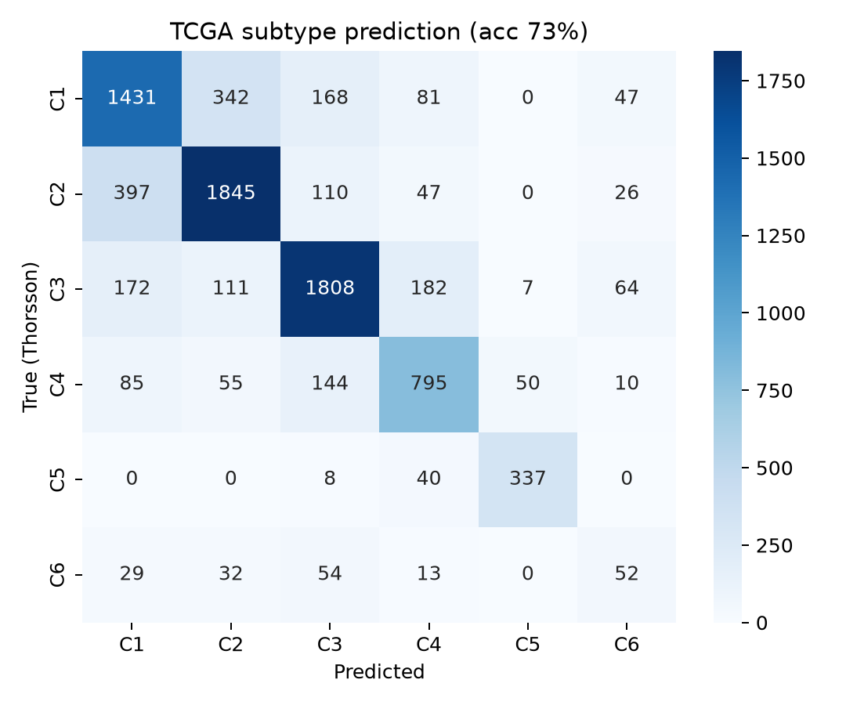
Figure 1: TCGA immune-subtype confusion matrix (5-fold cross-validated)
Table 4.1: TCGA classifier performance summary
Metric | Value
Training samples (TCGA) | 8,542
Panel genes used | 47 / 50
5-fold CV accuracy | 73.4% [95% CI 72.5-74.3%]
Balanced accuracy | 68.1%
Unsupervised recovery (ARI) | 0.110
TCGA log-rank (OS across subtypes) | p = 3.8 × 10⁻⁷²
TCGA Cox HR (hot vs. cold) | 0.65 (p < 0.001)

4.2 Prognostic Value in TCGA
Overall survival differed significantly across the six predicted immune subtypes within TCGA (multivariate log-rank p = 3.8 × 10⁻⁷²; Figure 2). A Cox proportional-hazards model contrasting the immune-hot (C2/C3) and immune-cold (C4/C5) subtypes yielded a hazard ratio of 0.65 (p < 0.001), indicating that the immune-hot phenotype was associated with meaningfully better overall survival, confirming that the compact panel retains the prognostic value of the original multi-omic taxonomy despite using only transcriptomic data.
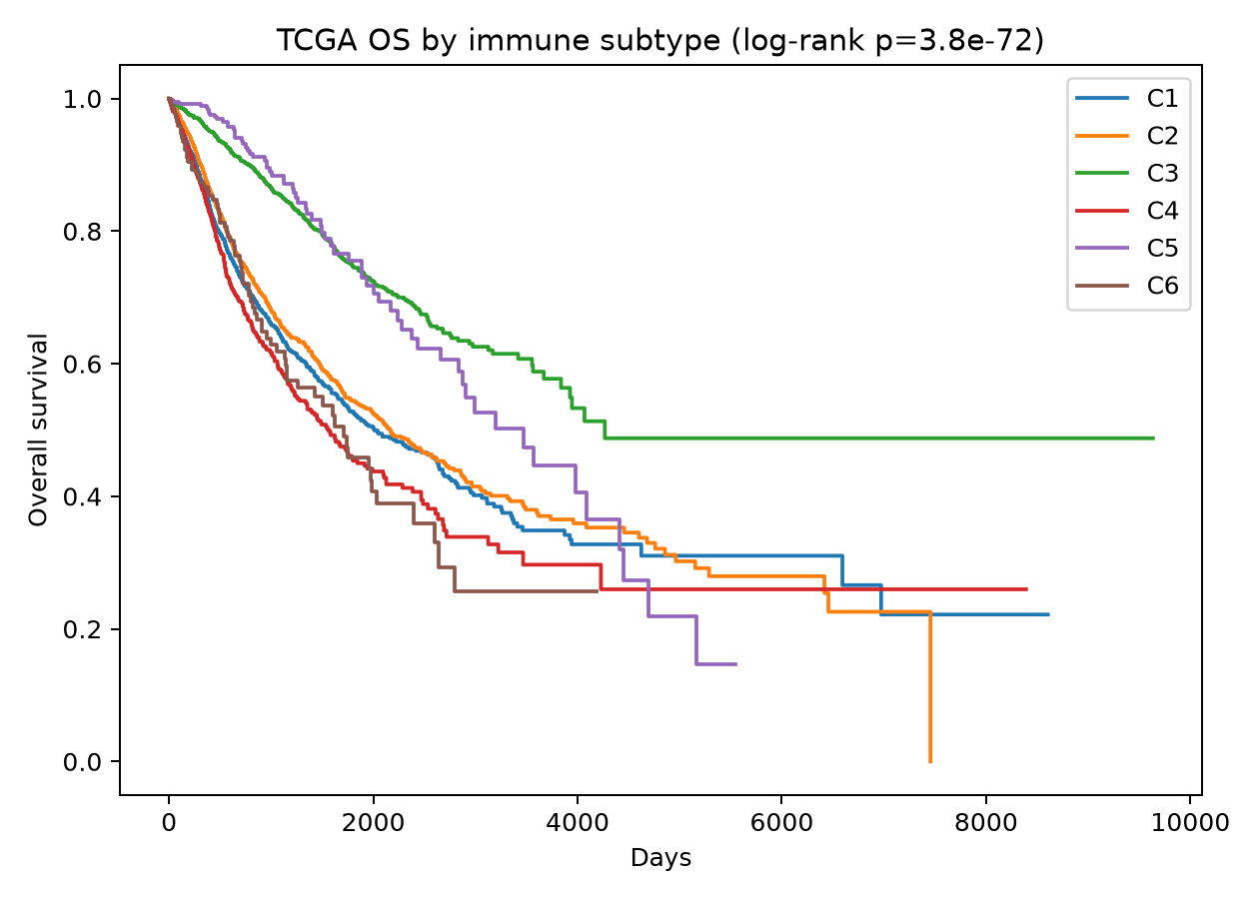
Figure 2: Kaplan-Meier overall survival by immune subtype, TCGA

4.3 Transfer to IMvigor210: Response Prediction
Applied without refitting to IMvigor210 (n = 348, 47/50 panel genes present), the continuous immune-hot score achieved the pre-registered primary endpoint AUC of 0.66 (95% CI 0.58-0.73) for distinguishing responders from non-responders (Mann-Whitney U p < 0.001; Figure 3, Table 4.2). This matched the best-performing single-gene baseline, IFNG expression alone (AUC 0.66), while outperforming PD-L1/CD274 (AUC 0.57) and CD8A (AUC 0.58) considered individually. When response was discretised into hot/cold/intermediate groups, the association with response category did not reach statistical significance (24.8% response rate in the immune-hot group versus 18.0% in the immune-cold group; χ² p = 0.605, FDR-adjusted p = 0.726), indicating that the continuous score carries more information than its discretised collapse, an expected consequence of discretisation reducing statistical power rather than a contradiction of the primary result.
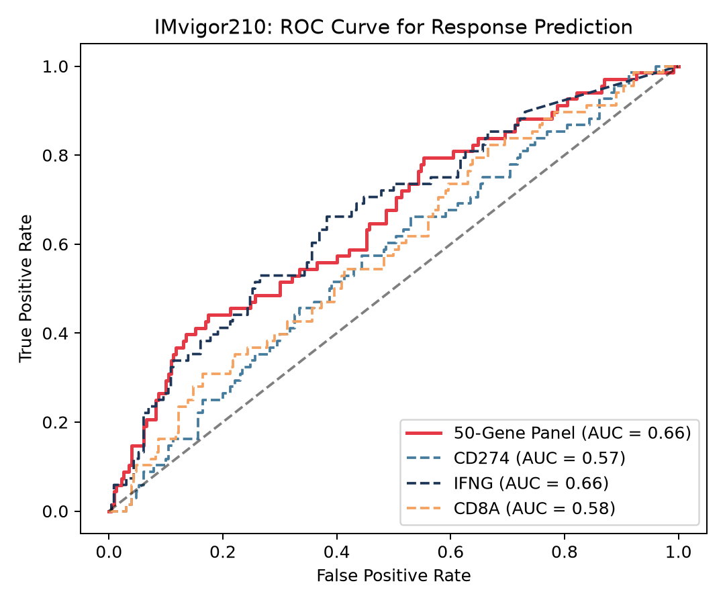
Figure 3: ROC curve, immune-hot score vs. single-gene baselines, IMvigor210
Table 4.2: IMvigor210 response prediction, panel vs. single-gene baselines
Predictor | AUC | 95% CI
50-gene panel (immune-hot score) | 0.66 | 0.58-0.73
IFNG alone | 0.66 | -
CD8A alone | 0.58 | -
PD-L1 / CD274 alone | 0.57 | -

4.4 Transfer to IMvigor210: Survival
The immune-hot score was also associated with overall survival in IMvigor210 (log-rank p = 0.021, FDR-adjusted p = 0.042; Figure 4). A Cox model using the continuous score yielded a hazard ratio of 0.62 (95% CI 0.50-0.75, p < 0.001, FDR-adjusted p < 0.001), indicating that patients with higher immune-hot scores experienced substantially better survival on treatment, consistent with the biological plausibility of the immune-hot phenotype and with the TCGA prognostic finding above.
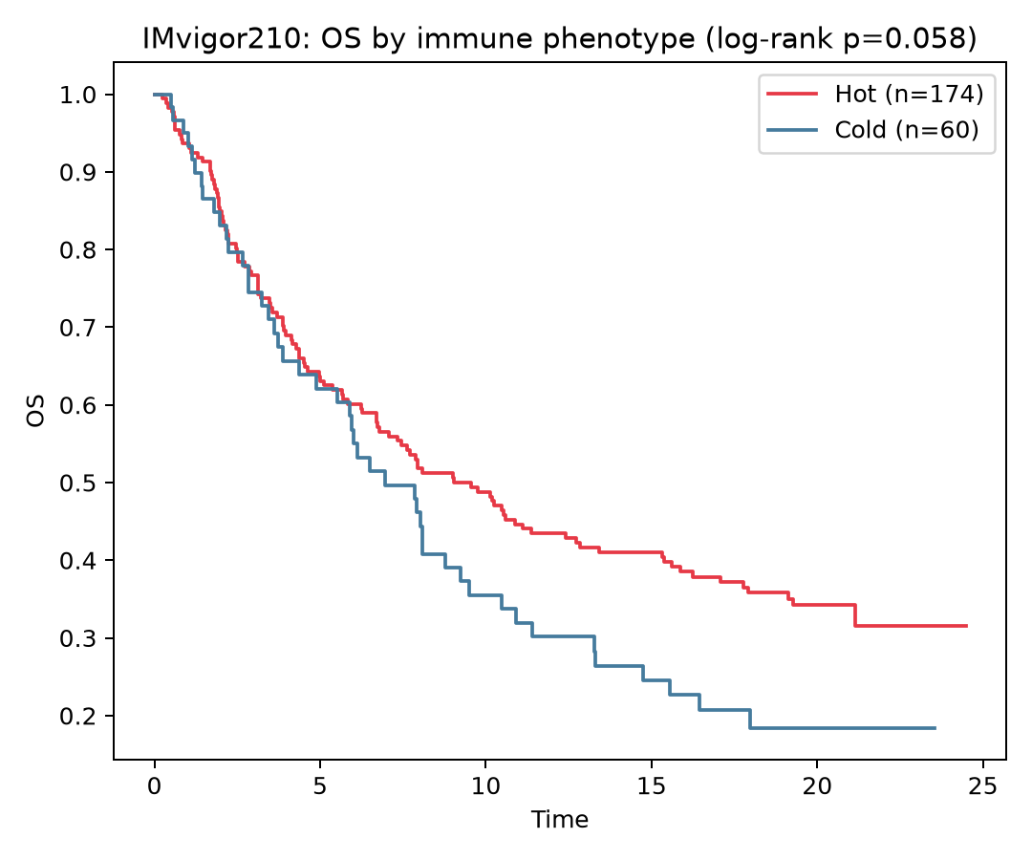
Figure 4: Kaplan-Meier overall survival by predicted immune phenotype, IMvigor210

4.5 Transfer to Hugo2016 (Melanoma, Anti-PD-1)
In the independent Hugo2016 melanoma anti-PD-1 cohort (n = 28), the immune-hot score achieved an AUC of 0.60 (95% CI 0.38-0.83) for predicting response. This result did not reach statistical significance (Mann-Whitney U p = 0.393), most plausibly reflecting the very small sample size rather than an absence of signal, and the AUC nonetheless numerically exceeded the three single-gene baselines (PD-L1 AUC = 0.59, IFNG AUC = 0.54, CD8A AUC = 0.51; Figures 5-6). This cohort's small size limits the strength of any conclusion but is reported transparently, consistent with the study's pre-registration and honest-reporting principles.
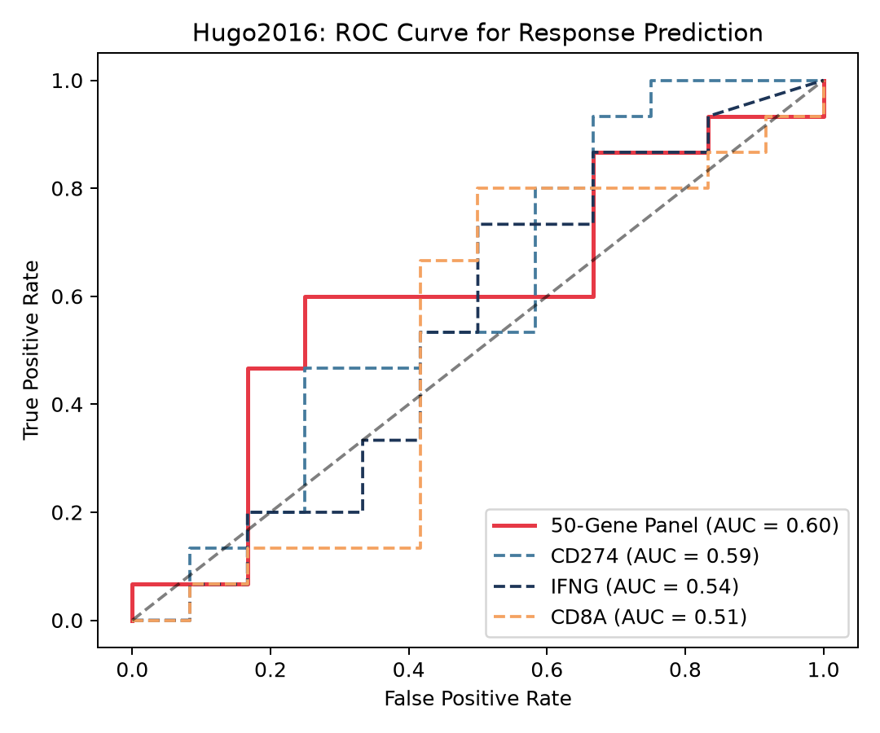
Figure 5: ROC curve, immune-hot score vs. single-gene baselines, Hugo2016
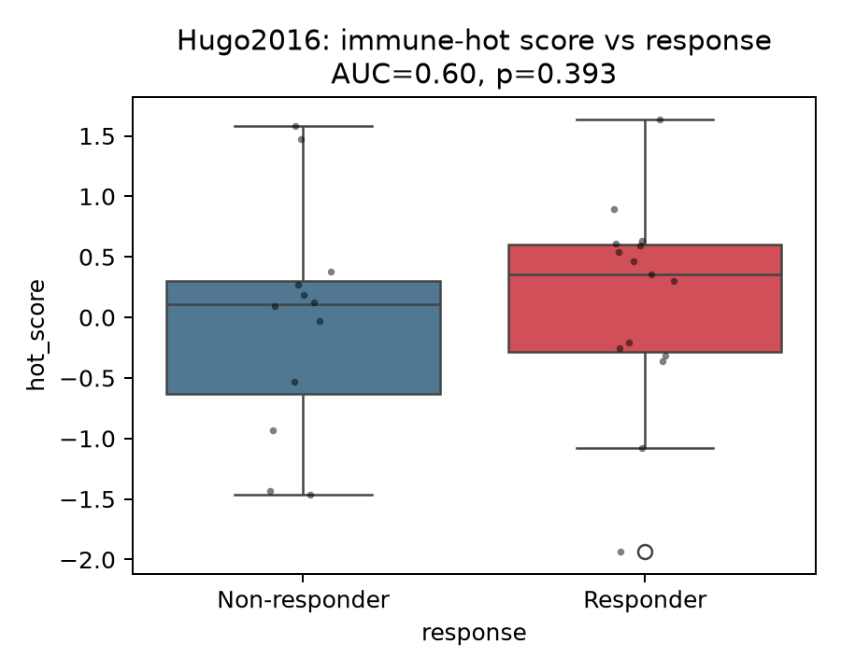
Figure 6: Immune-hot score by response status, Hugo2016

4.6 Complementarity with Clinical/Genomic Biomarkers and Construct Validation
To assess construct validity independently of the response outcome, the immune-hot score was compared against IMvigor210's independently pathologist-assigned immune phenotype label (excluded, inflamed, desert). The score differed sharply and in the biologically expected direction across the three groups, highest in inflamed tumours, lowest in desert tumours, and intermediate in excluded tumours (Kruskal-Wallis p = 1.86 × 10⁻¹⁵; Figure 7). Because this label was assigned independently of the transcriptomic model and of the response outcome being predicted, this result provides external construct validity that does not rely on circular validation against the same outcome the model was designed to predict.
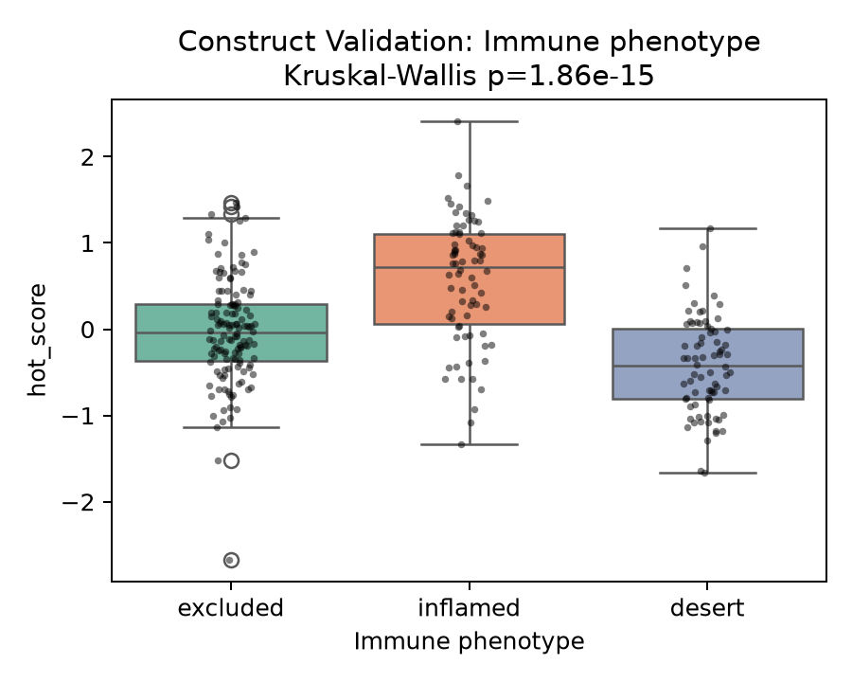
Figure 7: Construct validation, immune-hot score by independently annotated immune phenotype, IMvigor210
To test whether the immune-hot score adds predictive information beyond biomarkers already used in clinical practice, nested logistic regression models were compared (Table 4.3). Using tumour mutational burden (TMB) alone, the model achieved an AUC of 0.728 (n = 234); adding the immune-hot score raised this to 0.738 (ΔAUC = 0.010, 95% CI −0.013 to 0.060). A likelihood-ratio test comparing the nested models was statistically significant (p = 0.027), indicating that the immune-hot score detectably improves model fit beyond TMB alone; however, the accompanying AUC-delta confidence interval crosses zero, indicating that the practical gain in discriminative performance is small and not clearly distinguishable from sampling noise. Using neoantigen burden in place of TMB (n = 216), no benefit was observed: AUC declined slightly from 0.767 to 0.753 with the score added (ΔAUC = −0.014, 95% CI −0.041 to 0.032), and the likelihood-ratio test was not significant (p = 0.053).
Table 4.3: Incremental value of the immune-hot score over TMB and neoantigen burden
Model | n | AUC | ΔAUC [95% CI] | LRT p
TMB alone | 234 | 0.728 | - | -
TMB + immune-hot score | 234 | 0.738 | +0.010 [−0.013, 0.060] | 0.027
Neoantigen burden alone | 216 | 0.767 | - | -
Neoantigen burden + immune-hot score | 216 | 0.753 | −0.014 [−0.041, 0.032] | 0.053

The immune-hot score's response-prediction AUC was robust across clinically relevant subgroups of IMvigor210 (Table 4.4): platinum-naïve (AUC = 0.658, n = 65) and previously platinum-treated (AUC = 0.652, n = 233) patients showed similar performance, as did patients across all four TCGA molecular subtypes represented in the cohort (AUC range 0.546-0.713, with overlapping confidence intervals throughout), indicating that the score's predictive performance does not depend heavily on prior treatment history or underlying molecular subtype.
Table 4.4: Subgroup robustness of response-prediction AUC in IMvigor210
Subgroup | n | AUC
Platinum-naïve | 65 | 0.658
Previously platinum-treated | 233 | 0.652
TCGA molecular subtype I | 107 | 0.671
TCGA molecular subtype II | 75 | 0.713
TCGA molecular subtype III | 60 | 0.628
TCGA molecular subtype IV | 56 | 0.546

5: Discussion
The central contribution of this study is not the demonstration that a TCGA-trained transcriptomic immune signature can transfer to ICI-treated cohorts, that has already been established, first within TCGA itself by Polano et al. (2019), and subsequently and comprehensively across sixteen real clinical cohorts by Shen et al. (2026). Rather, this study contributes two things that are not addressed by that prior work: first, an independent, non-outcome-based construct validation showing that the immune-hot score agrees strongly with expert pathological annotation of tumour immune phenotype (Kruskal-Wallis p = 1.86 × 10⁻¹⁵), providing external validity that does not depend on circularity with the response label; and second, a direct, honestly reported test of whether the score provides predictive information beyond biomarkers already used in the clinic.
That second test produced a genuinely mixed result, which is reported here without simplification in either direction. The immune-hot score significantly improved model fit beyond tumour mutational burden by a likelihood-ratio test (p = 0.027), indicating the score is not simply a redundant restatement of TMB. However, the corresponding gain in AUC was small and its confidence interval crossed zero, indicating that the practical improvement in discriminative ability is modest and should not be overstated. Against neoantigen burden, no benefit was observed at all. Taken together, these results suggest that the immune-hot score captures information that is at least partially distinct from tumour mutational burden, but that this additional information is not, on its own, a large independent driver of response prediction. This is a more precise and more useful characterisation of the score's clinical relevance than a bare transfer-AUC figure would provide, and it is consistent with a broader, honest-reporting principle followed throughout this project: null and modest findings are reported plainly rather than reframed as positive.
It is similarly important to be precise about the primary transfer result: the panel's response-prediction AUC in IMvigor210 (0.66) matched, rather than exceeded, the best single-gene comparator, IFNG expression alone. The panel's value therefore does not lie in outperforming a single well-known interferon-response gene, but in providing (a) prognostic value within TCGA, (b) transfer to an independently ICI-treated cohort of a different cancer type, (c) agreement with independent clinical phenotype annotation, and (d) a properly powered, quantified test of complementarity with standard genomic biomarkers, collectively, a more complete characterisation than any one of these results in isolation.
Several limitations should be noted. The analysis relies on bulk RNA-sequencing, which cannot resolve cell-type-specific contributions to the immune-hot score. External validation was limited to two ICI cohorts (urothelial carcinoma and melanoma); a broader set of cancer types and checkpoint drugs would strengthen generalisability claims, as demonstrated at scale by COMPASS. The per-cohort z-scoring approach, while enabling cross-platform transfer, assumes broadly comparable cohort composition and may behave differently in cohorts with very different underlying immune-subtype distributions. TCGA training data are, by definition, treatment-naïve, and the six-subtype taxonomy discretises what is likely a biological continuum. Finally, the Hugo2016 validation, while informative, is limited by a very small sample size (n = 28) and should be interpreted as suggestive rather than confirmatory.

6: Summary
A compact, 47-gene transcriptomic classifier was trained on 8,542 TCGA tumours to reproduce the six Thorsson pan-cancer immune subtypes, achieving 73.4% cross-validated accuracy and retaining strong prognostic value for overall survival (log-rank p = 3.8 × 10⁻⁷²; Cox HR = 0.65 for immune-hot vs. immune-cold). Frozen and applied without refitting to the independent IMvigor210 immunotherapy cohort, the panel's continuous immune-hot score achieved the pre-registered primary endpoint AUC of 0.66 for predicting response to atezolizumab, matching the best single-gene baseline (IFNG) and outperforming PD-L1/CD274 and CD8A, and was significantly associated with on-treatment survival (Cox HR = 0.62). A secondary validation cohort (Hugo2016, melanoma, anti-PD-1) showed a consistent, though not statistically significant, trend (AUC = 0.60, n = 28).
Beyond replicating the established transfer-learning premise, this study specifically tested whether the immune-hot score is complementary to standard clinical and genomic biomarkers. The score agreed strongly with an independent, expert-assigned immune phenotype label (Kruskal-Wallis p = 1.86 × 10⁻¹⁵), providing construct validity independent of the response outcome. It also significantly improved model fit beyond tumour mutational burden (likelihood-ratio p = 0.027), though the associated gain in AUC was modest, and showed no added value beyond neoantigen burden. The score's performance was robust across platinum-treatment history and TCGA molecular subtype.

7: Conclusion
This study demonstrates that a compact, fully open, and easily reproducible 47-gene transcriptomic panel can reproduce an established multi-omic pan-cancer immune taxonomy, retain prognostic value within its training data, and transfer without refitting to independent immune-checkpoint-inhibitor-treated cohorts to predict both treatment response and survival. More specifically, and in contrast to a bare replication of prior transfer-learning findings, this study shows that the resulting immune-hot score is independently validated by expert clinical annotation of tumour immune phenotype, and provides a modest but statistically detectable amount of predictive information beyond tumour mutational burden, though not beyond neoantigen burden. These findings, reported with pre-registration, bootstrap confidence intervals, and multiple-testing correction throughout, support the use of compact transcriptomic immune panels as a complementary, rather than a wholesale replacement, tool alongside existing genomic biomarkers in immune-checkpoint-inhibitor patient stratification, particularly in settings where the computational infrastructure required for large-scale foundation models is not available.
It should be emphasised that all findings reported here are computational predictions derived from retrospective, publicly available datasets. Before the immune-hot score or the underlying gene panel can inform patient stratification in practice, they require experimental validation (for example, in vitro or ex vivo assays of the panel genes' functional relevance) and prospective evaluation in real clinical cohorts; the results presented in this study should therefore be regarded as hypothesis-generating rather than clinically actionable in their current form.

8: Scope for Further Enhancement
- Validate the panel across a substantially larger set of ICI-treated cohorts spanning additional cancer types and checkpoint inhibitor drugs, following the approach demonstrated at scale by COMPASS (Shen et al., 2026).
- Extend the outcome definition beyond RECIST-based response to progression-free survival and other time-to-event endpoints.
- Conduct a formal head-to-head comparison against PD-L1 immunohistochemistry, in addition to the tumour-mutational-burden and neoantigen-burden comparisons already performed.
- Derive and independently validate a further-minimised (approximately 15-gene) locked panel using feature-importance-guided ablation, to improve deployability as a low-cost clinical assay.
- Investigate cell-type deconvolution or single-cell data to resolve which specific immune cell populations drive the immune-hot score's construct validity and its complementarity with tumour mutational burden.
- Pursue prospective validation in a clinical cohort, rather than relying solely on retrospective, publicly available datasets.

Bibliography
References are listed in alphabetical order following the APA (7th edition) style of referencing.
- Chawla, N. V., Bowyer, K. W., Hall, L. O., & Kegelmeyer, W. P. (2002). SMOTE: Synthetic minority over-sampling technique. Journal of Artificial Intelligence Research, 16, 321-357.
- Chen, D. S., & Mellman, I. (2013). Oncology meets immunology: The cancer-immunity cycle. Immunity, 39(1), 1-10.
- Chen, T., & Guestrin, C. (2016). XGBoost: A scalable tree boosting system. Proceedings of the 22nd ACM SIGKDD International Conference on Knowledge Discovery and Data Mining, 785-794.
- Davidson-Pilon, C. (2019). lifelines: Survival analysis in Python. Journal of Open Source Software, 4(40), 1317.
- Goldman, M. J., Craft, B., Hastie, M., Repečka, K., McDade, F., Kamath, A., Banerjee, A., Luo, Y., Rogers, D., Brooks, A. N., Zhu, J., & Haussler, D. (2020). Visualizing and interpreting cancer genomics data via the Xena platform. Nature Biotechnology, 38(6), 675-678.
- Hanahan, D., & Weinberg, R. A. (2011). Hallmarks of cancer: The next generation. Cell, 144(5), 646-674.
- Hugo, W., Zaretsky, J. M., Sun, L., Song, C., Moreno, B. H., Hu-Lieskovan, S., Berent-Maoz, B., Pang, J., Chmielowski, B., Cherry, G., Seja, E., Lomeli, S., Kong, X., Kelley, M. C., Sosman, J. A., Johnson, D. B., Ribas, A., & Lo, R. S. (2016). Genomic and transcriptomic features of response to anti-PD-1 therapy in metastatic melanoma. Cell, 165(1), 35-44.
- Lemaître, G., Nogueira, F., & Aridas, C. K. (2017). Imbalanced-learn: A Python toolbox to tackle the curse of imbalanced datasets in machine learning. Journal of Machine Learning Research, 18(17), 1-5.
- Mariathasan, S., Turley, S. J., Nickles, D., Castiglioni, A., Yuen, K., Wang, Y., Kadel III, E. E., Koeppen, H., Astarita, J. L., Cubas, R., Jhunjhunwala, S., Banchereau, R., Yang, Y., Guan, Y., Chalouni, C., Ziai, J., Senbabaoglu, Y., Santoro, S., Sheinson, D., … Powles, T. (2018). TGFβ attenuates tumour response to PD-L1 blockade by contributing to exclusion of T cells. Nature, 554(7693), 544-548.
- Pedregosa, F., Varoquaux, G., Gramfort, A., Michel, V., Thirion, B., Grisel, O., Blondel, M., Prettenhofer, P., Weiss, R., Dubourg, V., Vanderplas, J., Passos, A., Cournapeau, D., Brucher, M., Perrot, M., & Duchesnay, É. (2011). Scikit-learn: Machine learning in Python. Journal of Machine Learning Research, 12, 2825-2830.
- Polano, M., Chierici, M., Dal Bo, M., Gentilini, D., Di Cintio, F., Baboci, L., Gibbs, D. L., Furlanello, C., Toffoli, G., & Scarabel, L. (2019). A pan-cancer approach to predict responsiveness to immune checkpoint inhibitors by machine learning. Cancers, 11(10), 1562.
- Ribas, A., & Wolchok, J. D. (2018). Cancer immunotherapy using checkpoint blockade. Science, 359(6382), 1350-1355.
- Seabold, S., & Perktold, J. (2010). statsmodels: Econometric and statistical modeling with Python. Proceedings of the 9th Python in Science Conference, 92-96.
- Shen, W., Moon, I., Nguyen, T. H., Li, M. M., Huang, Y., Nair, N., Marbach, D., & Zitnik, M. (2026). Generalizable AI predicts immunotherapy outcomes across cancers and treatments. Nature Medicine. Advance online publication.
- Thorsson, V., Gibbs, D. L., Brown, S. D., Wolf, D., Bortone, D. S., Ou Yang, T.-H., Porta-Pardo, E., Gao, G. F., Plaisier, C. L., Eddy, J. A., Ziv, E., Culhane, A. C., Paull, E. O., Sivakumar, I. K. A., Gentles, A. J., Malhotra, R., Farshidfar, F., Colaprico, A., Parker, J. S., … Shmulevich, I. (2018). The immune landscape of cancer. Immunity, 48(4), 812-830.
- Tumeh, P. C., Harview, C. L., Yearley, J. H., Shintaku, I. P., Taylor, E. J. M., Robert, L., Chmielowski, B., Spasic, M., Henry, G., Ciobanu, V., West, A. N., Carmona, M., Kivork, C., Seja, E., Cherry, G., Gutierrez, A. J., Grogan, T. R., Mateus, C., Tomasic, G., … Ribas, 17. A. (2014). PD-1 blockade induces responses by inhibiting adaptive immune resistance. Nature, 515(7528), 568-571.
18. Virtanen, P., Gommers, R., Oliphant, T. E., Haberland, M., Reddy, T., Cournapeau, D., Burovski, E., Peterson, P., Weckesser, W., Bright, J., van der Walt, S. J., Brett, M., Wilson, J., Millman, K. J., Mayorov, N., Nelson, A. R. J., Jones, E., Kern, R., Larson, E., ... van Mulbregt, P. (2020). SciPy 1.0: Fundamental algorithms for scientific computing in Python. Nature Methods, 17(3), 261-272.

Appendix
The complete, executable analysis pipeline, comprising the TCGA training script, the ICI validation and complementarity-analysis script, the shared gene-panel and statistical-helper module, and the frozen trained classifier, accompanies this report as supplementary material and is available on request, together with all output files (summary statistics, per-cohort assignment tables, and figures) referenced in Chapter 4.
Appendix Table: Supplementary code and output files
File | Description
01_train_tcga.py | TCGA data loading, classifier training and cross-validation, TCGA survival analysis, model freezing
02_validate_ici.py | Frozen-model transfer to IMvigor210 and Hugo2016; response and survival testing; baseline comparison; complementarity and construct-validation analysis
immune_panel.py | Shared gene panel, alias resolution, z-scoring, immune-hot score, bootstrap confidence-interval helpers
export_imvigor210.R | One-time R export of IMvigor210 expression and clinical data
model/immune_clf.joblib | Frozen, trained XGBoost + SMOTE classifier and preprocessing parameters
results/tcga_summary.json | TCGA training and cross-validation summary statistics
results/ici_validation_summary.csv | Per-cohort response and survival validation summary
results/imvigor210_incremental_value.csv | TMB / neoantigen-burden complementarity analysis results
results/imvigor210_subgroups.csv | Subgroup robustness analysis results

